**13006101 - Introduction to Computers and Programming**

**Semester 1/2015**

**Project: Email Client**

**Project Developer:**

Name: Mr. Supachai Mohamed Abusali ID: 58090039

**Project Title:**

Python Email Client

**Project Description:**

The ultimate purpose of this program is to create an alternative method to send emails with the use of a very simple and interactive Graphical User Interface (GUI). The features provided in the program are the ability to connect to the internet and connect to the preferred email server with the use of a username and password, the program only allows the user to send an email to a single recipient and the context of the email should be in a text format. The user also has the ability to log in into a different account or the same account after the user logs out. The primary modules that this program uses are the *tkinter* module and the *smtplib* module, these modules are already available in the standard library of Python 3.

**Output:**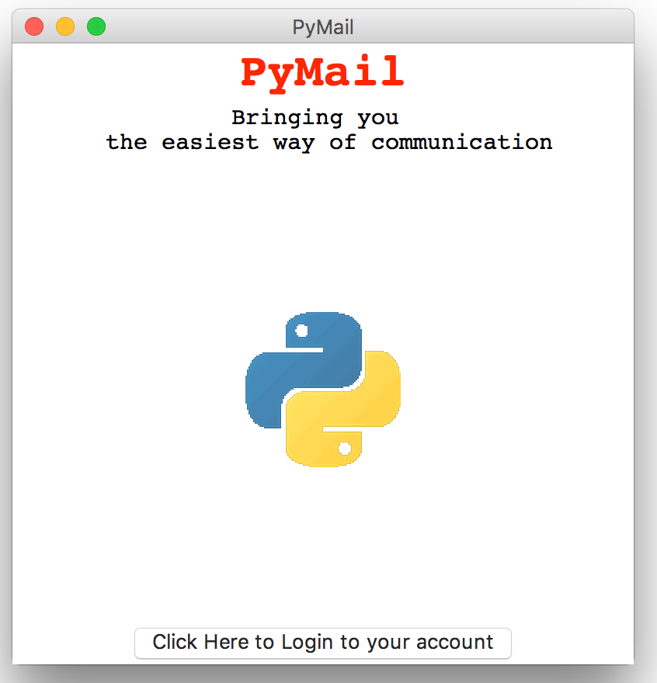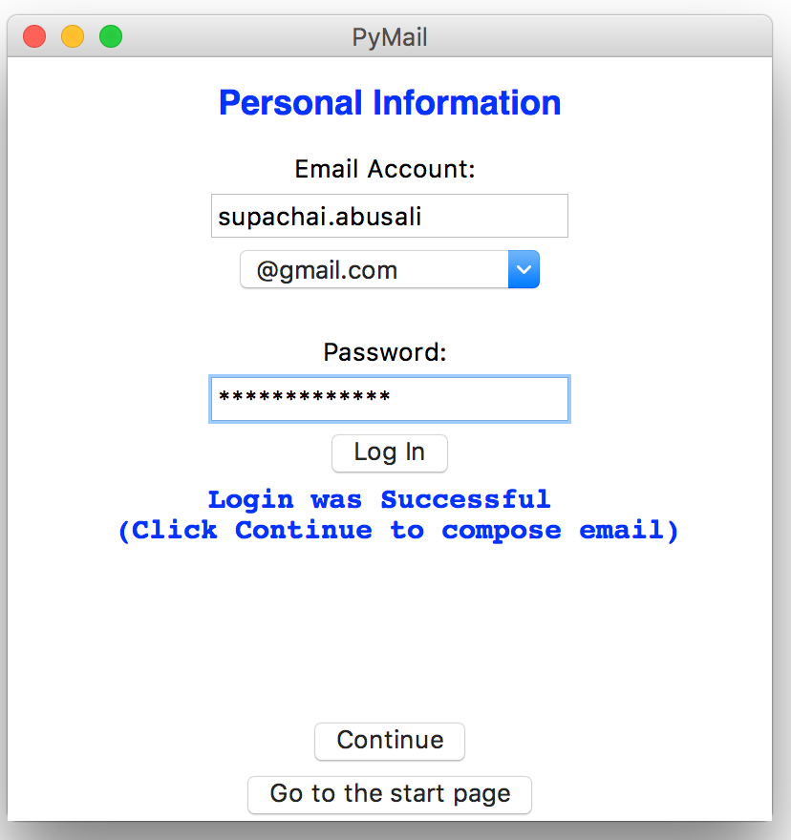

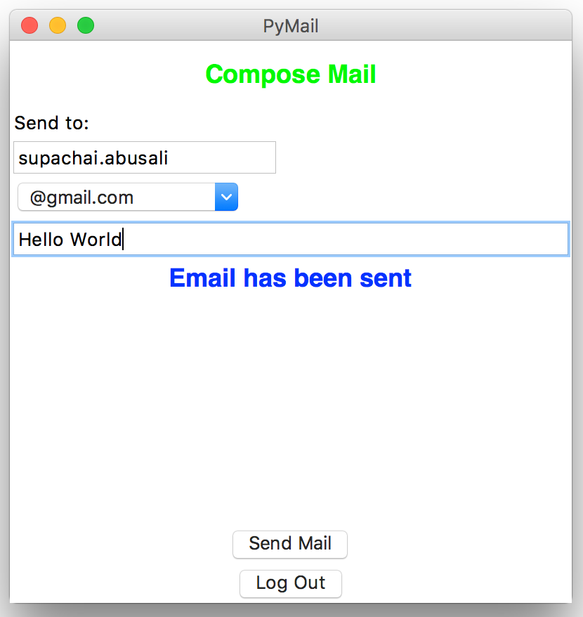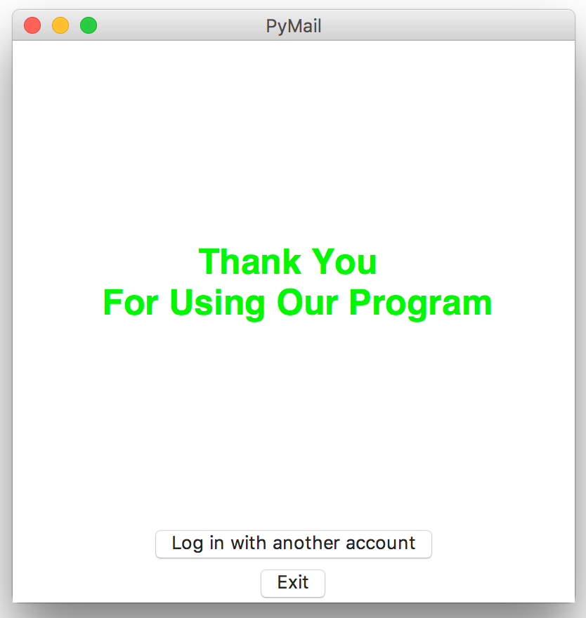

**Source Code:**